Name : _____________________ Date: ___________ Period: _____

Mathematics Narrative Writing Prompt

Prompt : You are going to the grocery store for your mom. She has asked you to buy her five items to help her bake a cake for your sister’s birthday. Your mom has asked you to buy eggs, flour, milk, cake mix, and frosting. She has given you twenty dollars to spend. Write a narrative story (an account from your point of view) that explains your trip to the grocery store.

Paragraph 1 (Introduction)
Items to think about on your journey to the store-
-How will you get to the store? Who did you take with you?
-How long will the trip take and what was the rate at which you travelled (at how many Miles Per Hour)?
-Describe your trip to the store

Paragraph 2 (body)
-Seeing as you only have twenty dollars, how much will each item cost?
-What kind of each item will you buy (sprinkles with frosting, perhaps?)?
-What was your total at the store and how much money will you have left over?
-Please include sensory details (using your five senses, describe your experience at the store- what did you see? Smell? Hear? Touch? Taste?)

Paragraph 3 (conclusion)
-Describe the cake, be sure to include sensory details, taste, smell…
-Remember- You are telling a story about your experience. Make sure that you include details that would make the story interesting to the reader (Did you meet anyone exciting in the vegetable section? Did the milk accidently explode when you took it off of the shelf in the refrigerated section?

-Write at least 1 page essay to address all the questions from the prompt

A personal narrative shares an important experience from the writer's life. Here are step-by-step directions to help you write a personal narrative.
1. Prewriting
- Select an important experience you had. Gather and organize details about it
- Use a thinking map to help you organize your thoughts.
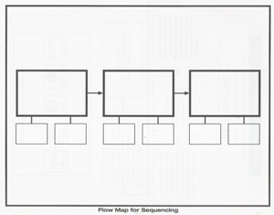
2. Writing
- Imporove your wok by making sure the events are clear and well ordered, and the voice is interesting.

3. Revising
- Improve your work by making sure each step is clear and the process is complete.

4. Editing
- Check for style and accuracy, and prepare a final copy.

